**Exp 2.2**

**Name – Rahul Maurya**

**UID – 20BCS7260**

**Group/Section – 716B**

**Subject – Software Engineering Lab**

**Question – 2 -** [**Bank ATM UML use case diagrams examples**](https://www.uml-diagrams.org/bank-atm-uml-use-case-diagram-example.html?context=uc-examples)

**Purpose**: Describe use cases that an automated teller machine (ATM) or the automatic banking machine (ABM) provides to the bank customers.

**Summary**: Customer uses a bank ATM to check balances of his/her bank accounts, deposit funds, withdraw cash and/or transfer funds (use cases). ATM Technician provides maintenance and repairs to the ATM.

**Solution -** An automated teller machine (**ATM**) or the automatic banking machine (**ABM**) is a banking subsystem (**subject**) that provides bank customers with access to financial transactions in a public space without the need for a cashier, clerk, or bank teller.

Customer (**actor**) uses bank ATM to Check Balances of his/her bank accounts, Deposit Funds, Withdraw Cash and/or Transfer Funds (**use cases**). ATM Technician provides Maintenance and Repairs. All these use cases also involve Bank actor whether it is related to customer transactions or to the ATM servicing.

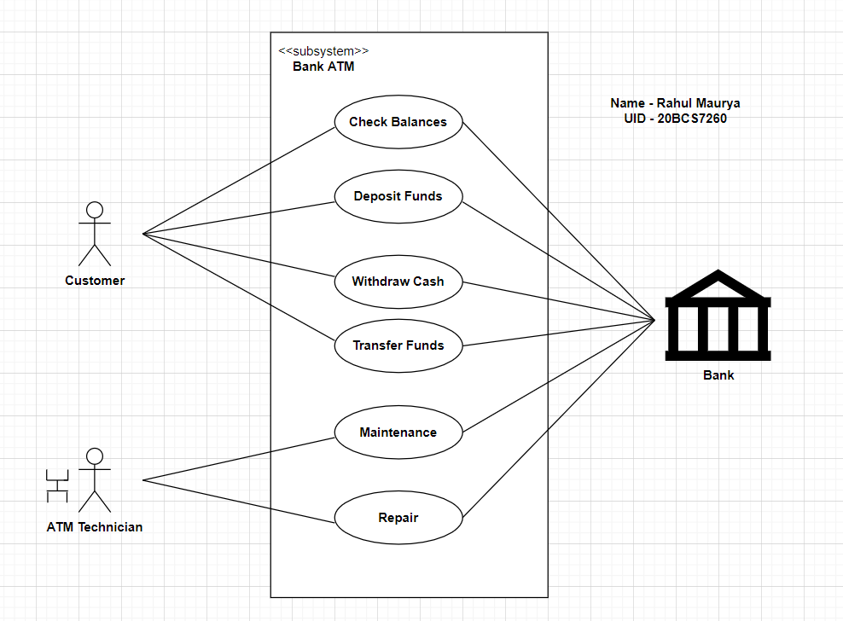

An example of use case diagram for Bank ATM subsystem - top level use cases.

On most bank ATMs, the customer is authenticated by inserting a plastic ATM card and entering a personal identification number (PIN). Customer Authentication use case is required for every ATM transaction so we show it as include relationship. Including this use case as well as transaction generalizations make the ATM Transaction an abstract use case.

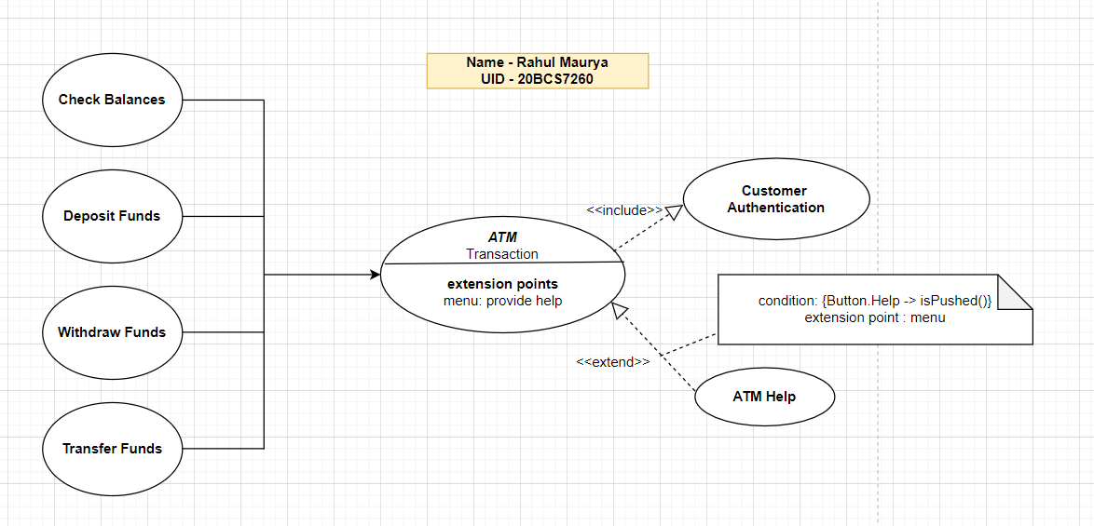

Bank ATM Transactions and Customer Authentication Use Cases Example.

Customer may need some help from the ATM. ATM Transaction use case is extended via extension point called menu by the ATM Help use case whenever ATM Transaction is at the location specified by the menu and the bank customer requests help, e.g., by selecting Help menu item.

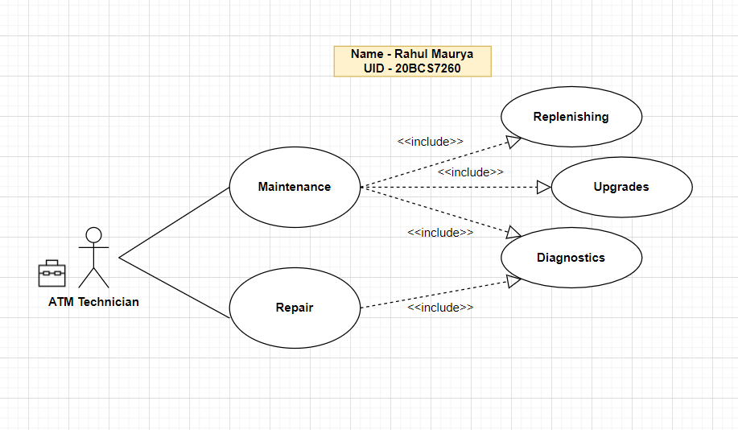

Bank ATM Maintenance, Repair, Diagnostics Use Cases Example.

ATM Technician maintainsor *repairs Bank* ATM*.*Maintenance*use case* includesReplenishingATMwith cash, ink or printer paper*,*Upgrades of hardware, firmware or software, and remote or on-site Diagnostics. Diagnostics is also included in (shared with) Repair use case.